West Texas Watercolor Society
http://wtws.org
Providing opportunity for the interchange of ideas in all forms of water media
June 2014 Vol. 28 Issue #5

Western Federation of Watercolors
Exhibition 40
April 16 – July 15, 2015
Museum of Texas Tech University
Lubbock, TX

WFWS consists of twelve watercolor societies with a total of around 4500 members.
The societies include, the San Diego Watercolor Society (SDWS), Southwestern Watercolor Society (SWS), Watercolor Society of Oregon (WSO), etc.
Anyone who is a member of one of the WFWS societies can enter the WFWS - 40 show. We will be exhibiting 100 juried paintings from around 1100 paintings submitted from the twelve societies.

The judge for the WFWS - 40 show is Linda Baker, NWS, AWS. She paints beautiful transparent watercolors using a pouring technique. While
she is here judging the show, she will give a demo
for WTWS as well as teach a workshop. Karla Bennett and Gale Webb are in charge of this workshop.
Start painting your masterpiece for the WFWS - 40!!!!
Let’s see a large number of WTWS members entering this show!

The prospectus can be downloaded. CLICK HERE

Carol Peterson, delegate

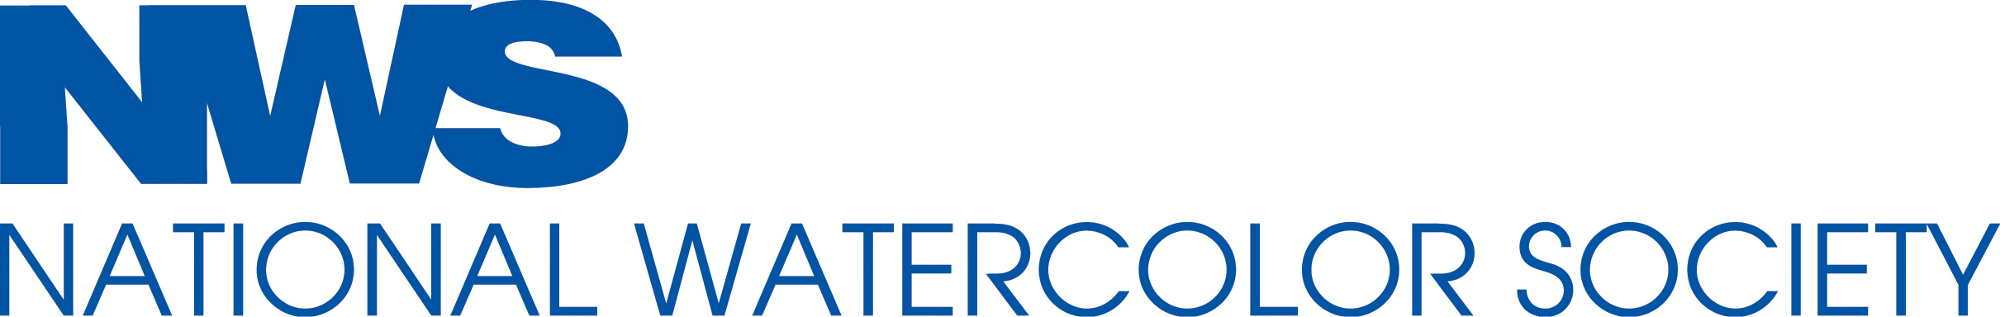Deadline: July 31, 2014

National Watercolor Society 94th International
Exhibition, November 8, 2014 - January 11, 2015. NWS Gallery, 915 S. Pacific Ave., San Pedro, CA 90731. Opening and reception: November 8, 2014. $40,000+ in Awards. Jury of Selection: Katherine Chang Liu, chair, John Salminen, Carole Barnes. Juror of Awards: Jean Stern, Ex. Dir., Irvine Museum. Prospectus at www.nationalwatercolorsociety.org or email NWSAnnualExhib@gmail.com or SASE to NWS Gallery at above address. Check website for Annual Demos and Workshops.

WTWS SPRING SHOW 2014
WINNER

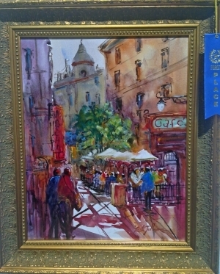
1st Place Advanced / Professional – Jo Beth Gilliam

CONGRATULATIONS TO
JIMMY DAVIS

Jimmy has a painting accepted in the San Diego Watercolor Society's 34th International Exhibition to be held in October. This is the third time that he has been accepted into that show.

CONGRATULATIONS TO
SUZY POWELL

Suzy was accepted into the 23rd Breckinridge Juried Art Show. July29-Sept.6

UPCOMING
CLASSES AND WORKSHOPS
Suzy Powell is having 2 workshops at her new Backyard Studio and Gallery

Sketchbook Class
2 day sketchbook class, September 12-13, $80 for both days. Contact Suzy at Suzy_pal2000@yahoo.com
Love Your Life
Art Journaling class by
Nancy Standlee

Oct 17-18 Nancy Standlee from Dallas is coming to do journaling entitled 'love your Life' $175.00. Contact Suzy at Suzy_pal2000@yahoo.com
Portrait Workshop
Carol Peterson

October 4, Saturday, 2014
Amarillo, TX
For more information or to signup contact
Cherine Kuster, icolor@cmycolors.com, 806-331-3811.

Save the Date – July 26
Annalee
Annalee will teach a free-to-members mini workshop on watercolor batik at the Legacy. More information to follow.

YOAKUM ART SHOW

It is that time of year again!
Our art show starts with check in Tuesday July 29th 10-6 and ends Saturday August 2nd at 4 pm.
Entry fee is $5.00. Awards are $100 for best in show. $25 1st $15 2nd $10 3rd
The show will be at the Plains Community Center in Plains. One block west of Lowes Grocery Store. We need all the entries we can get! It would be great to have a full building.
John Hope from Levelland is the judge.

