West Texas Watercolor Society
http://wtws.org
Providing opportunity for the interchange of ideas in all forms of water media
August 2014 Vol. 28 Issue #6

Western Federation of Watercolors
Exhibition 40
April 16 – July 15, 2015
Museum of Texas Tech University
Lubbock, TX

WFWS consists of twelve watercolor societies with a total of around 4500 members.
The societies include, the San Diego Watercolor Society (SDWS), Southwestern Watercolor Society (SWS), Watercolor Society of Oregon (WSO), etc.
Anyone who is a member of one of the WFWS societies can enter the WFWS - 40 show. We will be exhibiting 100 juried paintings from around 1100 paintings submitted from the twelve societies.

The judge for the WFWS - 40 show is Linda Baker, NWS, AWS. She paints beautiful transparent watercolors using a pouring technique. While
she is here judging the show, she will give a demo
for WTWS as well as teach a workshop. Karla Bennett and Gale Webb are in charge of this workshop.
Start painting your masterpiece for the WFWS - 40!!!!
Let’s see a large number of WTWS members entering this show!

The prospectus can be downloaded. CLICK HERE

Carol Peterson, delegate

THANK YOU ANNALEE
A Big Thank You goes out to our Fearless leader Annalee Schubert for hosting a great member event.
It was a dynamic day for all there with a few “oops” from yours truly.
Adventuring with friends, learning something new and being there when the “ah-ha” moment revealed a spectacular painting!
Our membership is truly a gifted lot and I hope in the future we can have more of these exciting and nourishing events.
Thank You Annalee from all of us
You are awe-inspiring
June

CONGRATULATIONS TO
SUZY POWELL
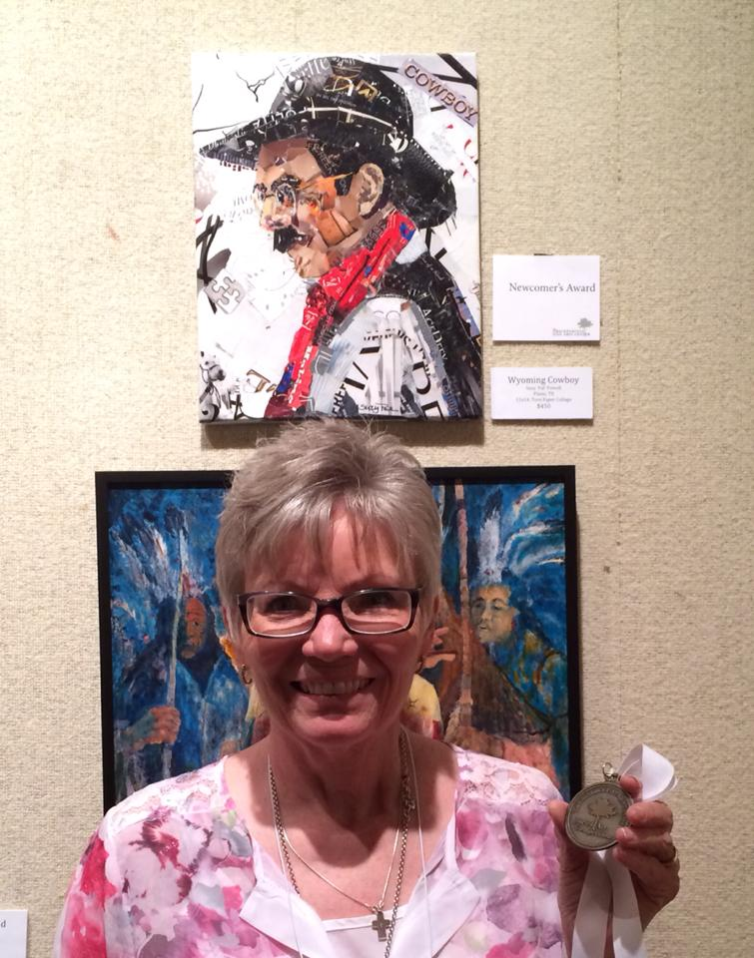

Suzy is definitely a winner. She won 1st in 3 division at the Yoakum Art Show and she won an award at the Breckenridge TX art show
Texture Acrylics Demo
Stand Back you will need a little room for all the Stuff that goes into one of these paintings!
Texture, color and a lot of fun comes along for the ride when creating a texture collage.
Using Acrylic Mediums and white papers: This demo will give insight on how to layer and use mediums to create a non-subjective painting using a formula or a collage type on canvas or paper using only white papers like watercolor paper, tissue, masa, rice etc.
Come and visit us August 10th at the Garden and Arts Center to witness this creation right in front of your eyes!
But beware it’s contagious and you could catch the bug!

UPCOMING
CLASSES AND WORKSHOPS
Suzy Powell is having 2 workshops at her new Backyard Studio and Gallery

Sketchbook Class
2 day sketchbook class, September 12-13, $80 for both days. Contact Suzy at Suzy_pal2000@yahoo.com
Love Your Life
Art Journaling class by
Nancy Standlee

Oct 17-18 Nancy Standlee from Dallas is coming to do journaling entitled 'Love your Life' $175.00. Contact Suzy at Suzy_pal2000@yahoo.com
Portrait Workshop
Carol Peterson

October 4, Saturday, 2014
Amarillo, TX
For more information or to signup contact
Cherine Kuster, icolor@cmycolors.com,
806-331-3811.

Visiting Artists Workshops

Santa Fe, New Mexico Artist Julie Schumer is an abstract expressionist artist who creates landscape and figurative images in a variety of media.

WTWS Hosts a 3 day workshop October 23rd through the 26th 2014 at the Louise Hopkins Underwood Center of the Arts. Total price is $300.00 with $100.00 of that due as a deposit. The deposit is refundable if cancellation is made 60 days before the workshop begins. See her work at her website www.julieschumer.com

Linda Baker, an internationally known watercolorist, will teach a workshop for WTWS April 27 - May 1st, 2015 at the Texas Tech University Museum. She will also give a demo for the membership on Sunday, May 26th, 2015. The workshop will cost $450 for five days.
Please send inquiries to jcadams1949@gmail.com or June Musick jamart2011@gmail.com
(Make deposits payable to WTWS)
West Texas Watercolor Society
P.O.Box 2022
Lubbock, Texas 79408

Newsletter goodies- nathkelley@yahoo.com
Note-make sure you put 2 “e”s in kelley

