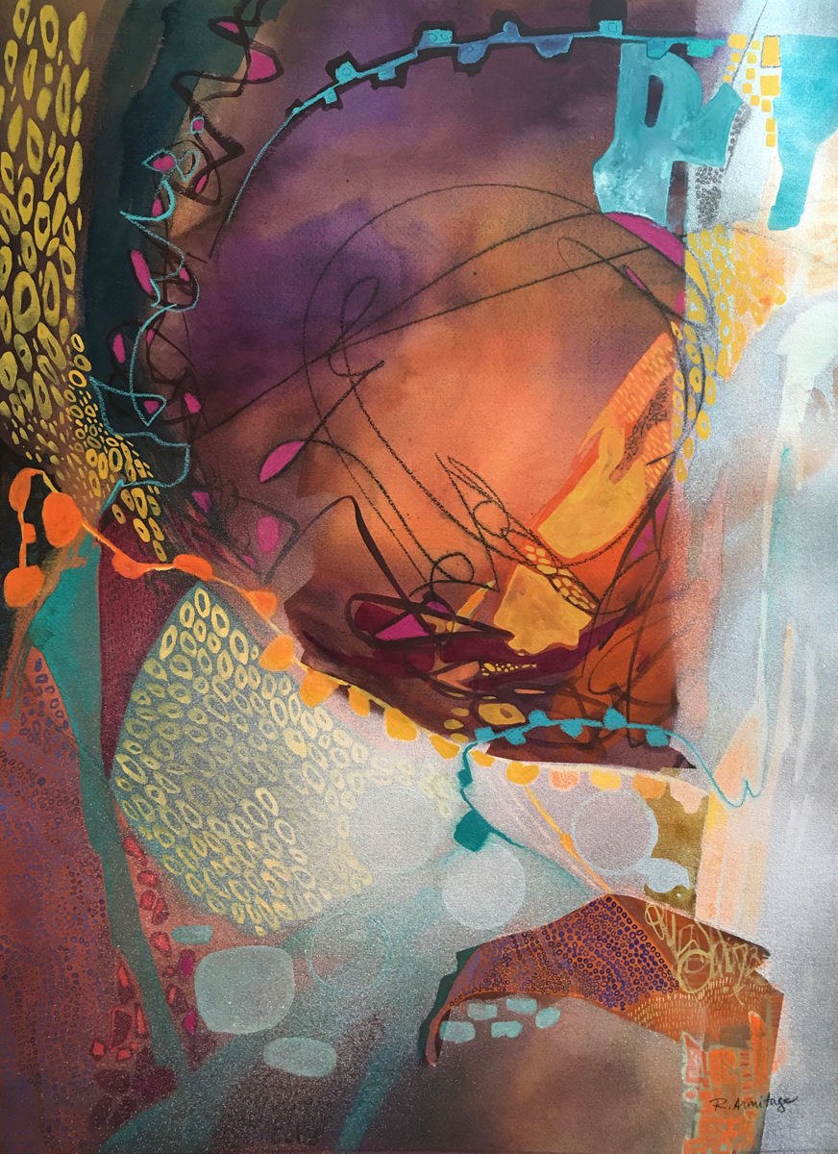

Ruth Armitage, NWS

Three Whites for Watercolorists

A Three Day Workshop

Join Ruth to explore three (or more) different ways to incorporate white into your watercolors. Look beyond saving whites with masking or negative painting and learn to use opaque media as more than an afterthought.

Ruth’s work has received many local and national awards, including the Loa Ruth Sprung Award in the NWS 95th Annual Open. She is a signature member of the NWS, RMNW, NWWS, WW, CWA and WFWS. Ruth has served as President of the Watercolor Society of Oregon and juried national, regional and local exhibits.